BASIC LINUX COMMANDS
1.LS COMMANDS
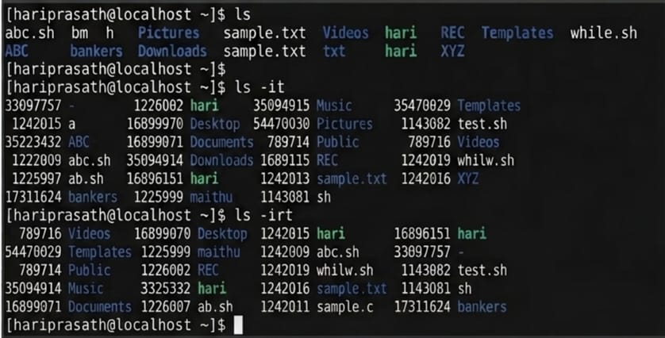
2.Vi,Pwd,touch,cat commands
